TailScale VPN
  - Quick Start Guide


TAble of
Contents
Emphasis Heading 1 1
Heading 2 1
Heading 2 2

Active Accounts
& Networks
This is meant to record active Tailscale accounts and networks that have been established as part of a development effort for the Applied Systems Laboratory (ASL) at University of Tennessee – Knoxville.

Heading 2
View and edit this document in Word on your computer, tablet, or phone. You can edit text; easily insert content such as pictures, shapes, or tables; and seamlessly save the document to the cloud from Word on your Windows, Mac, Android, or iOS device.
“Quote”
Want to insert a picture from your files or add a shape, text box, or table? You got it! On the Insert tab of the ribbon, just tap the option you need.
Find even more easy-to-use tools on the Insert tab, such as to add a hyperlink or insert a comment.

Heading 2
- Use styles to easily format your Word documents in no time. For example, this text uses the List Bullet style.
- On the Home tab of the ribbon, check out Styles to apply the formatting you want with just a tap.
 | Column Heading | Column Heading

TailScale VPN
  - Login / Signup

Start by navigating to the landing page for www.tailscale.com.
Signup

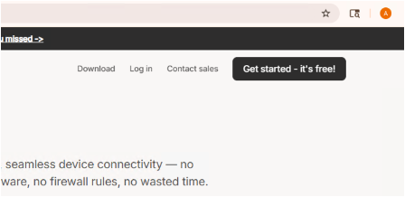
In the top right corner of the page, select “Get Started – It’s Free”.

The next screen will provide several options for signing up.
Select the option that works best for you.
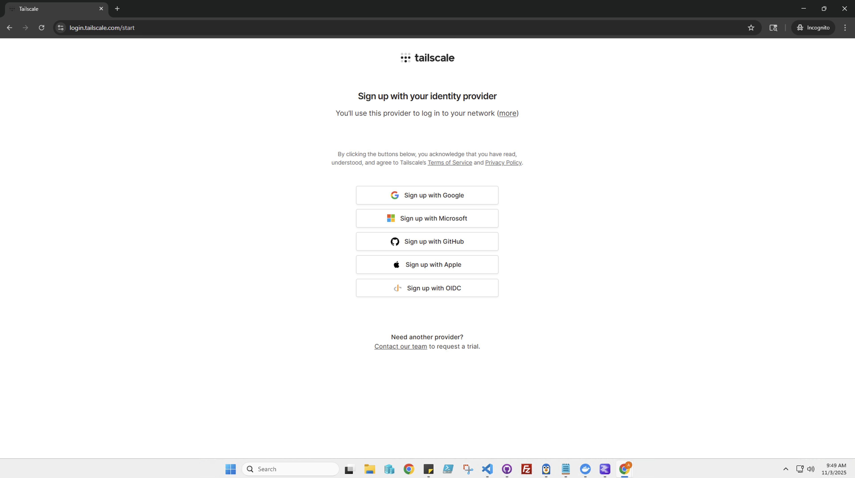
Upon creating an account, you will be prompted to download the software. Select the installation based on the target operating system.
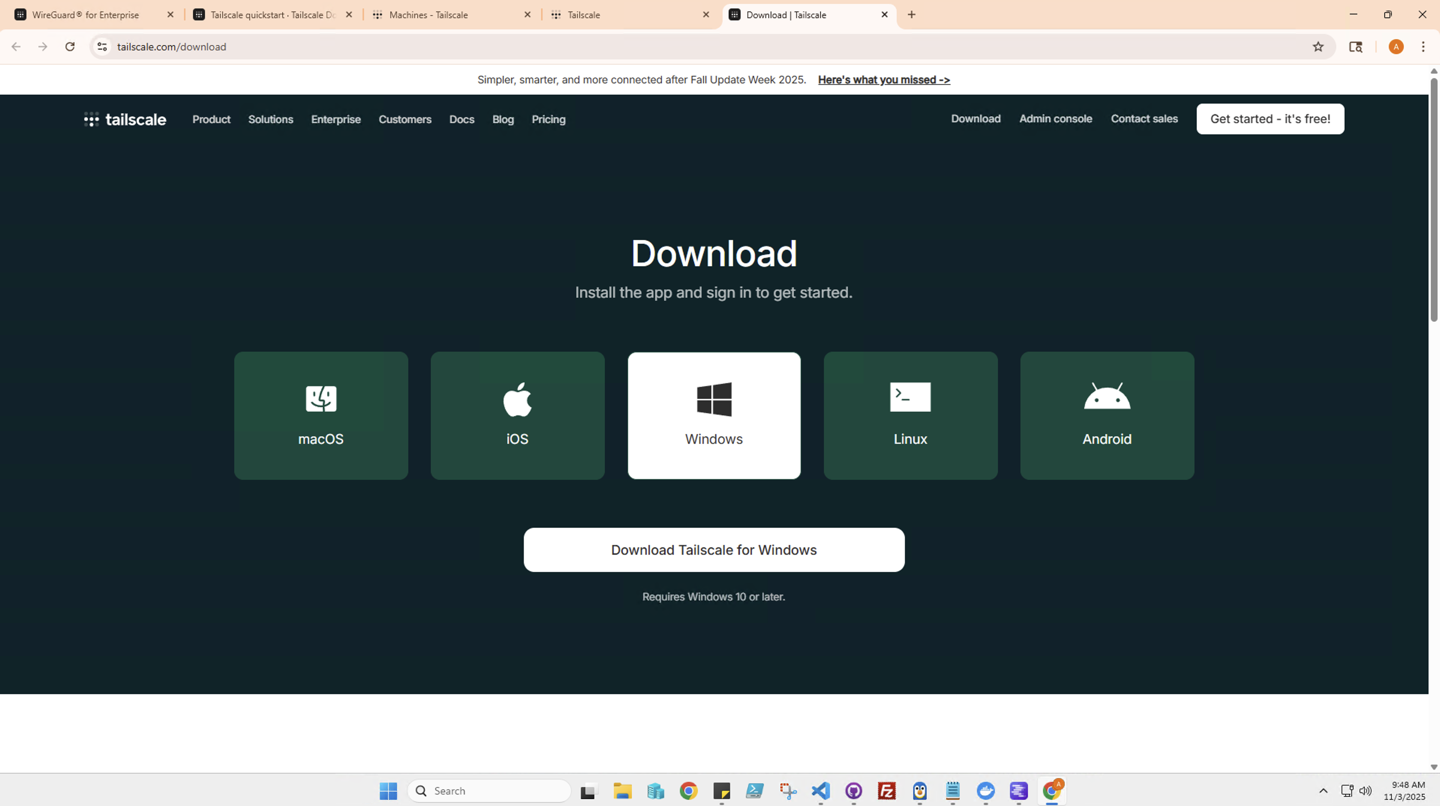

Login

In the top right corner of the page, select “Log In”.
On the next screen, use the provided email and password:
Email: icm4asl@gmail.com
Password: icm4asl2025
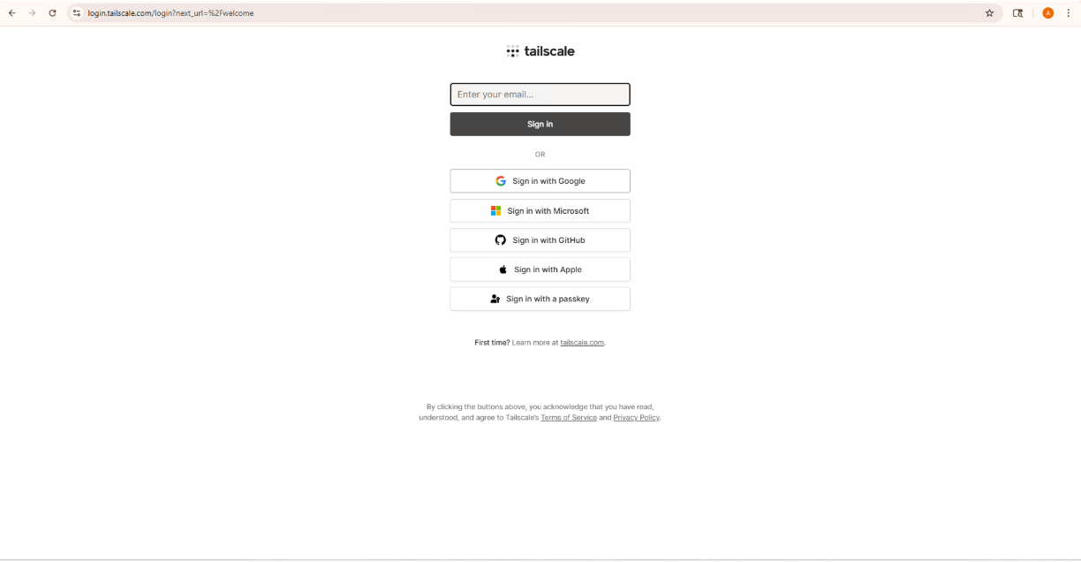
After successfully logging in, you will be redirected to the account page. 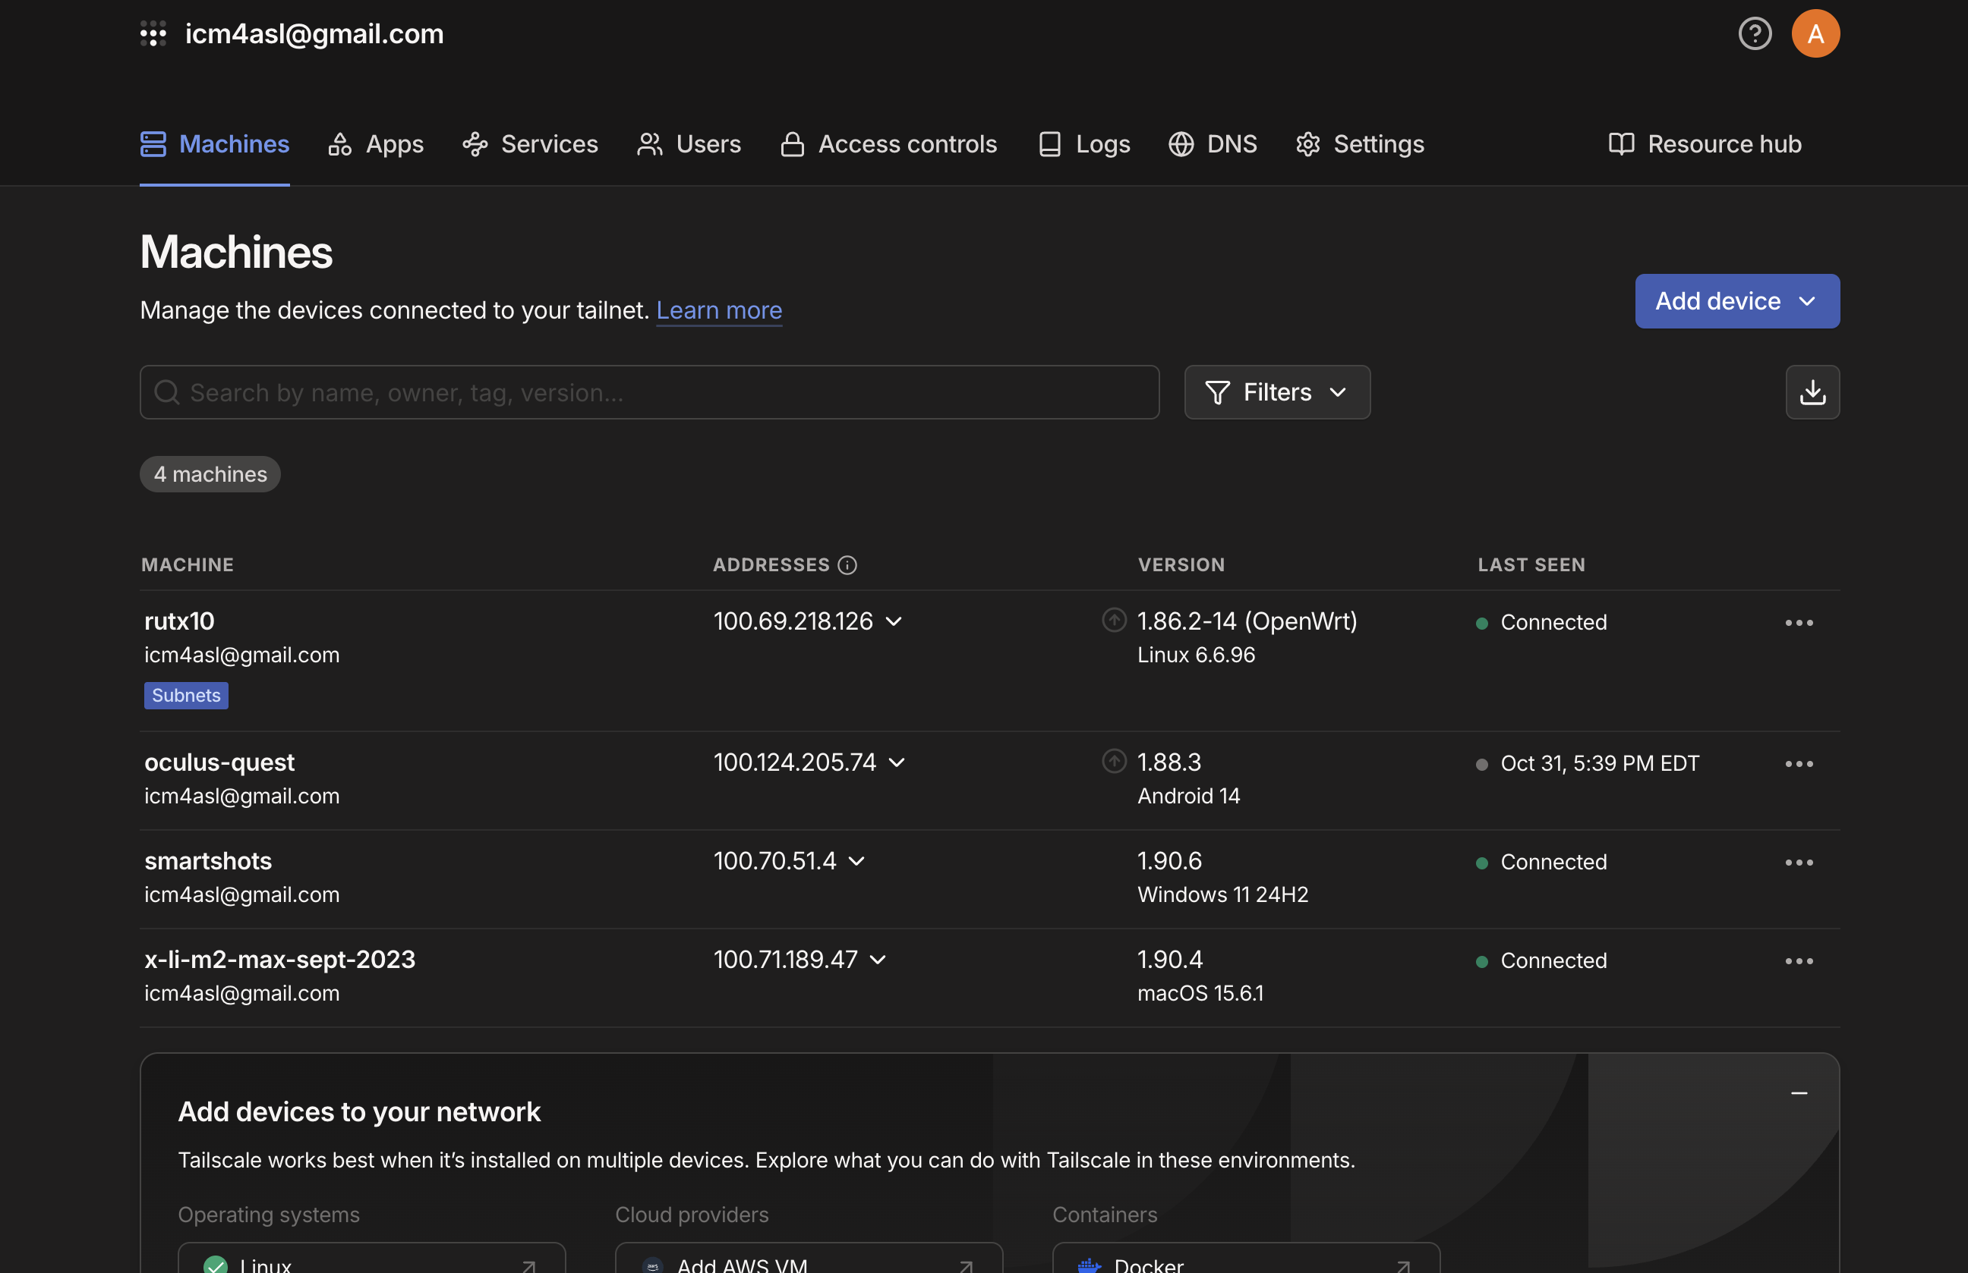

Row Heading | Text | 123.45
Row Heading | Text | 123.45

